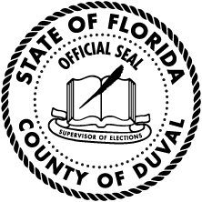
Affidavit of Intention
Duval County Special District Candidates
State of Florida
Duval County

I __________________________________________________ a candidate for the special district
Print name

office of ______________________________________________________________ in the general
District name including district, seat or group number

election certify that I will not collect, solicit, or accept any contribution; be it a gift, subscription,
conveyance, deposit, loan, payment, or distribution of money or anything of value including contributions
in kind having an attributable monetary value in any form, made for the purpose of influencing the results
of an election (106.011(3), Florida Statutes). I further certify that the only expenditure made on behalf of
my candidacy will be the candidate qualifying fee or, in lieu of the qualifying fee, the signature verification
fee for candidate petitions.

I certify that in the event I collect, solicit, or accept any contribution, as described above, or make a campaign expenditure; be it a purchase, payment, distribution, loan, advance, transfer of funds by a campaign treasure or deputy campaign treasurer between a primary depository and a separate interest-bearing account or certificates of deposit, or gift of money or anything of value made for the purpose of influencing the results
of an election (106.011(4), Florida Statutes) my campaign will be governed by Chapter 106, Florida Statutes.
UNDER PENALTIES OF PERJURY, I DECLARE THAT I HAVE READ THE FOREGOING
AFIDAVIT AND THAT THE FACTS STATED IN IT ARE TRUE.
________________________________________________________________ ______________________
Signature of Candidate Date
Rev. 1/2018

